Kulbatyrov N., Tulepbekova A.
JSC Economic Research Institute, Kazakhstan

THE NEW SILK ROAD: TRANSPORT INTEGRATION OF ECO MEMBER COUNTRIES

Abstract
Intensifying of competition for the global transit and the rapid development of economic cooperation and trade relations between Europe and Asia, which cannot be successful without effective organization of transport system, poses the new challenges before the transport and logistics system of the ECO member countries.
Historically, the sea transport has played a major role in providing trade flows between Europe and Asia. But today, the countries are taken into account new, alternative modes of transportation, in order to avoid the traffic by sea and to find a more competitive and attractive solutions. In this regard, the formation of an integrated transport system of the ECO member countries as never becomes relevant.

Actuality
Revival of the Great Silk Road will make a huge contribution to the collective prosperity of ECO member states that was repeatedly noted by the leaders of ECO member states. The Silk Road should be the corridor of energy, trade, transport and communications. In this regard, the further deepening of integration in transport and communication of ECO member states is the most important problem.
The revival of the "Great Silk Road" means the establishment of a comprehensive Eurasian transcontinental bridge. Freight traffic of the country, such as China, and the consumer market of Europe need the new schemes and proposals of transit countries, first of all this is the price for transport services, delivery time and, consequently, high-quality service. That’s why, in the context of globalization and the current needs in the rapid advancement of transportation services of goods, development of effective transport and logistics systems is critically important. The successful resolution of these issues is not possible without the partnership of the government and the international financial institutions.
Today the ECO region again has become in the center of interests of the leading countries of the world, the center of the revival of an open, progressive Islamic civilization and the birthplace of the Central Asian economic miracle. Due to its central geopolitical position, ECO and its individual members act as important bridge between this region and the other regions of the world.
Integration in transport sphere is one of the priorities of ECO cooperation at the regional level, which will facilitate trade in the region.
Formation of the regional transport system was started in the framework of the ten-year ECO program of action in the field of transport and communications, which was adopted at the summit in May 1997 in Ashgabat. In 1998, in Almaty, by the ECO members was signed a framework agreement about transit transport of goods and passengers. In addition, there were formed committees, working groups and programs for the various transportation sectors, including rail, road, sea transport, civil aviation, transportation and communication, and multimodal transport.
But despite the activities carried out by ECO members the problem of undeveloped transport communication system in the ECO region is still actual. This fact restrains the growth of intra-regional trade. The basis of transport system in the ECO region is railways, carries for more than 80% of freight and 50% of passenger traffic. That’s why the important direction of cooperation is the modernization and development of this sector.
Another problem is the different levels of cooperation among the ECO member countries, due to a number of reasons:
- Significant differences of levels of economic development of the ECO member countries;
- Unstable political situation in some countries of the region;
- Economic isolation of some ECO member countries.
There is still a low level of practical cooperation between the ECO member countries, which leads to underutilization of transport capacity in the region. There is low speed of freight on the ECO region due to poor coordination. In addition, there are such problems as non-optimal tariff policy of cargo, the lack of development of air traffic with the countries of the region, as well as the low technical level of the transport infrastructure of railways.
Analysis of the activities of the other Asian integration groups showed that the cooperative institutions contribute to the development of the economies of the member states. Therefore integration cooperation should be strengthened by combining the efforts of the Central Asian states for solutions of regional problems.

Trade and economic relations of the ECO member countries
Economic Cooperation Organization (ECO), established in 1985, consisting of ten member countries of the central and western Asia: Afghanistan, Azerbaijan, an, Kazakhstan, Kyrgyzstan, Pakistan, Tajikistan, Turkey, Turkmenistan and Uzbekistan, occupies almost 8 million square kilometers, 18.4 % of Asia and 5.3% of total world.
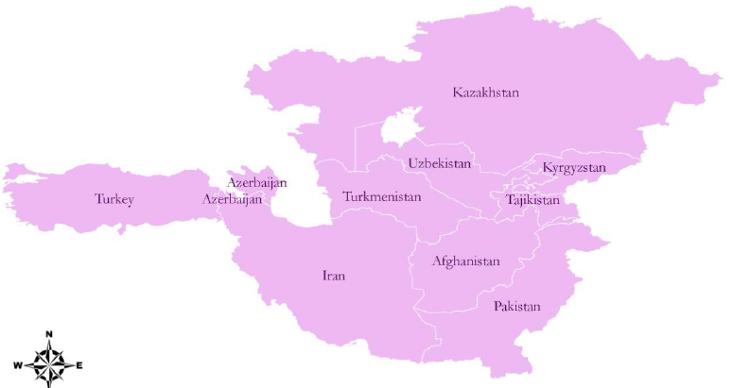
Map of ECO member states

The ECO region covers an area of ​​7 million. square kilometers with a population of over 430 million people that indicates the enormous economic potential of the ECO region.
Total GDP of all ECO countries at current prices experienced 14.6 % increase in 2011, compared with the previous year. Over the last two decades (1992-2011), value of total GDP of ECO countries became almost six times, from 315 billion US$ to 1,855 billion US$.
Total foreign trade of ECO region in 2012 estimated to 1,111 billion US$, composed of 865 Bln US$ as value of foreign trade of merchandise plus 246 Bln US$ as value of foreign trade of services. Share of ECO region in total world trade of merchandise in 2012 is equal to 2.3% while its share from total world trade of services, in a lower level, is estimated to 1.5%.
According to the official statistic Turkey has the largest share from total foreign trade of merchandise of the region with 45%. Iran (19 %) and Pakistan (16 %) are other two countries with higher share from total foreign trade of the region. The lowest share belongs to Tajikistan and Afghanistan for them this ratio is below one percent. Five countries of the region have added to their share from total foreign trade of merchandise of the region with the highest increase in Kazakhstan with 9.6%.

Total Foreign Trade of Merchandise of ECO Region and its share from total world in the years of period 1994-2012
Indicator | 1994 | 2000 | 2005 | 2010 | 2012
ECO Region (Bln US$) | 110 | 175 | 408 | 697 | 865
ECO/World (%) | 1.26 | 1.33 | 1.91 | 2.26 | 2.34

Turkey has the largest share of value of total foreign trade of merchandise of the region. Share of Turkey is 45 %, Iran has the second largest share of total foreign trade of the region with 18.6 % and in the next place, Kazakhstan with 15.8 percent stands in the third place. These three countries have four fifth of total foreign trade of the region in 2012.

Share of each ECO Country in total foreign trade of merchandise of the region, 2012

Value of total foreign trade of merchandise of ECO region amounted to 865,513 US$ in 2012. The maximum value belongs to Turkey with 152 Bln US$ in 2012, Iran - 104 Bln US$, Kazakhstan – 92 Bln US$, Azerbaijan – 32 and Pakistan – 24 Bln US$.

Exports and Imports of Merchandise of ECO Countries and share from Total Foreign Trade of the Region in 2012
Country | Value (Bln US$) |  |  | Percentage (%) |  |  | Regional share (%)
Country | Exports | Imports | Total | Exports | Imports | Total | Exports | Imports | Total
Afghanistan | 370 | 5,500 | 5,870 | 6.3 | 93.7 | 100 | 0.1 | 1.3 | 0.7
Azerbaijan | 32,634 | 10,417 | 43,051 | 75.8 | 24.2 | 100 | 7.5 | 2.4 | 5.0
Iran | 104,000 | 57,092 | 161,092 | 64.6 | 35.4 | 100 | 23.8 | 13.3 | 18.6
Kazakhstan | 92,286 | 44,539 | 136,825 | 67.4 | 32.6 | 100 | 21.1 | 10.4 | 15.8
Kyrgyz Republic | 1,894 | 5,374 | 7,268 | 26.1 | 73.9 | 100 | 0.4 | 1.3 | 0.8
Pakistan | 24,567 | 44,157 | 68,724 | 35.7 | 64.3 | 100 | 5.6 | 10.3 | 7.9
Tajikistan | 1,358 | 3,778 | 5,136 | 26.4 | 73.6 | 100 | 0.3 | 0.9 | 0.6
Turkey | 152,469 | 236,545 | 389,014 | 39.2 | 60.8 | 100 | 34.9 | 55.2 | 44.9
Turkmenistan | 16,500 | 9,900 | 26,400 | 62.5 | 37.5 | 100 | 3.8 | 2.3 | 3.1
Uzbekistan | 10,836 | 11,296 | 22,132 | 49.0 | 51.0 | 100 | 2.5 | 2.6 | 2.6
ECO Region | 436,914 | 428,599 | 865,513 | 50.5 | 49.5 | 100 | 100 | 100 | 100

One of the main objectives of the ECO is to promote economic cooperation and trade throughout the ECO region through facilitation of transport, in particular international road transport as the most important sector for achieving sustainable development and integration with global markets.
In this regard, the ECO Secretariat attaches priority to activities aimed at achieving progress in the following areas:
- to improve the road transport sector, in particular international road transport;
- to assist the governments of the member states in the improvement, simplification and harmonization of customs procedures and working conditions of international road transport;
- to support the development of effective systems of transport networks.
Improving of transport cooperation will contribute to the effectiveness of the expansion of trade in the region. But today, the existing trade and economic potential of the ECO region is not being fully used. This is largely due to the existing tariff and customs barriers that impede the exchange of goods in the ECO countries.

The transport system of the ECO
State of transport infrastructure is one of the determining factors for the economies of the ECO region, located between the capacious and dynamic markets of Europe, East and South-East Asia. The main direction of development of transport and communication systems of the ECO is the progressive integration into the global transport system. It means the realization of transit potential due to the attractiveness of their land communications, maritime and air space to international transport of passengers and cargo.
The total length of railways in the ECO region is about 51 182 km and roads is about 792 000 km.
The main objective of transport cooperation in ECO region is to accelerate the development of transport and communication infrastructure linking the ECO member states with each other and with the outside world. Therefore, the ECO operates in different directions:
- trucks have the opportunity to travel in ECO region in accordance with international standards;
- to expand and integrate the national rail network for simplifying transit transport by railway;
- to expand air service and cooperation in the field of civil aviation;
- to expand port facilities for handling marine cargo in the region;
- to facilitate the transit through improving the border crossing procedures between ECO member countries.
Development of regional transport system was initiated in the framework of a ten-year program of action of the ECO in the field of transport and communications, which was adopted at the summit in May 1997 in Ashgabat. In 1998, framework agreement about transit transport of goods and passengers was signed in Almaty. Also there were established committees, working groups and programs for the various transport sectors, including railway, road, maritime transport, civil aviation, transportation and communication, and multimodal transport.
ECO coordinates several projects in the field of railway infrastructure projects, particularly Kyrgyzstan - Tajikistan - Afghanistan - Iran, Kazakhstan - Turkmenistan - Iran Qazvin - Rasht - Astana. Today are already running container trains on routes to Islamabad - Tehran - Istanbul and Istanbul - Almaty, Bandar Abbas - Almaty and others.
According to the Framework Agreement on transit of the ECO and the Islamic Development Bank, there was prepared the comprehensive plan for the development of the railway network in the ECO region along the agreed railway corridors.
ECO uses several mechanisms for supporting interconnection of economies. Examples of such initiatives are practical system of electronic money transfers (total financial tool for postal services), white card scheme of ECO (for expansion of liability insurance of motor vehicles in respect of third parties) and a uniform visa for drivers.

Kazakhstan and ECO
Each country determines the strategy of development of transport infrastructure independently. Construction of multiple routes between Europe and Asia is in the interests of all countries of the Eurasian continent. Through the territory of Kazakhstan pass virtually all transportation corridors linking Europe and Asia.
Strengthening of competition attaches great importance to the development of transit-transport capacity of the ECO region as the main component of its exports of raw materials and goods.
It should be noted that for strengthening of own positions in the fight for transit cargo; many countries have begun to implement global projects. For example, the Russian Federation until 2015 plans to market of transport services “Trans-Siberian 7 days”, and until 2020 for the development of highway infrastructure is planned to invest about 6 billion US dollars.
In the framework of tripartite agreements between China, Kyrgyzstan and Uzbekistan construction of the railway route “Kashgar-Osh-Andijan” (433km) will be completed in 2018. This project focused on the first year of operation at least 5 million tons of cargo, and later it will rise till 15 million tons per year.
Arab Republic of Egypt has begun a project for the development of the Suez Canal until 2027. The aim of the project is the development of production and logistics clusters and increase revenue from $ 5.5 billion till 100 bln US dollars per year. Today through the Suez Canal passes about 10% of the total cargo of world trade.
Among the main prerequisites for increasing transit through Kazakhstan are the following. China is currently implementing a program of industrial development in the central and north-western regions “China Western Development planning 2011-2015”, which envisages the emergence of new industrial centers. Accelerated development of China’s western provinces will help to increase traffic through Kazakhstan.
Prerequisites for increasing goods turnover of the EU - China - EU are the following:
- The accelerated growth of the western provinces of China. A program of development of underdeveloped regions of Western China by state subsidies was adopted;
- High utilization of transport infrastructure in the East of China. Port infrastructure in the East China operates at peak capacity.
- High share of valuable goods in the structure of trade China-EU. The share of goods with high added value critical to the delivery times of up to 35% in the turnover of China-EU relations.
- Establishment of the Customs Union between Kazakhstan, Russia and Belorussia.
In October 1993 in Almaty during the 1st meeting of the Ministers of Transport and Communications of the ECO Member States was adopted Almaty master plan for transport infrastructure development in the ECO region. The realization of the Plan will connect roads and railways, airlines of ECO countries.
In accordance with this Plan, Kazakhstan held the systematic work for the creation of a modern and efficient transport network, corresponding to the world standards.
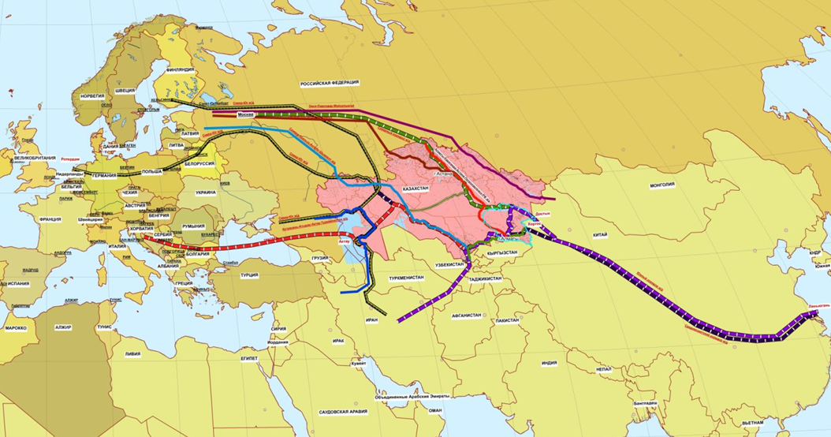
Kazakhstan in the international system of transport corridors

In 2012, Kazakhstan started large-scale project "Kazakhstan - New Silk Road", which aims at the appearance of Kazakhstan as a trade and logistics, finance and business, innovation and technology and tourism hubs. Successful implementation of the project requires the creation in the territory of Kazakhstan of modern transport and logistics system (road, railway, and air transport), ensuring high and efficient transport connectivity within the country and abroad, the increase in traffic on the territory of the Republic of Kazakhstan, the coordination of all land, sea ​​and air transport.
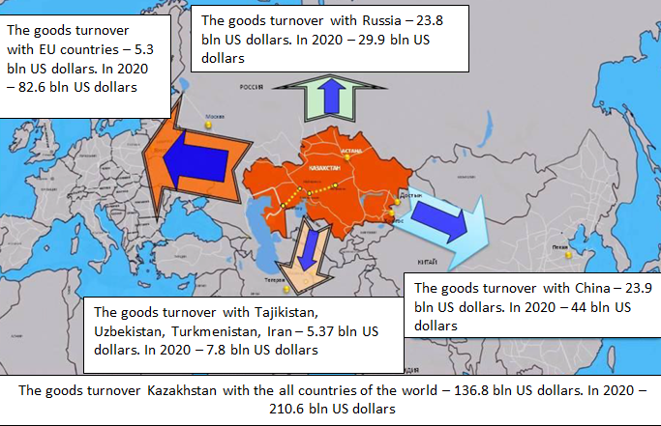
Transport positioning of Kazakhstan on the regional level

According to the experts forecast, the volume of exports of Kazakhstan in 2020 could grow by 1.5 times from 98 million tons to 147 million tons. This fact would require the transport and logistics service system additional cargo in Russia, China and South Korea, Europe, Central Asia. It is also expected that the volume of trade between the neighboring countries of Kazakhstan will increase by 1.5 times and will reach $ 1 trillion US dollars in 2020; it creates the potential of transit through Kazakhstan. The greatest growth of goods turnover is projected between China and the countries of Europe and Russia. That’s why the most perspective transit corridor is a corridor “China – Europe” and “China - the Russian Federation”.
Location of Kazakhstan in the center of the Eurasian continent between the major trading partners such as Europe and Asia dictates the main challenge for the development of the national transport system. China accounts about 50% of the trade between Europe and Asia. In 2013, the trade volume between China and the EU amounted more than 546 billion US dollars. At the same time the share of Kazakhstan in transiting this volume takes less than half a percent. In Kazakhstan, the share of logistics services does not exceed 1% of GDP, while in the leading European countries, logistics accounts over 7% of GDP.
International experts estimate that in 2020 container transport in the direction of China - EU will increase by 300 times, so Kazakhstan has the task of attracting 8% of transit traffic China - EU.
In order to develop the transport potential Kazakhstan implements a number of projects. Construction of railway line “Zheskazgan – Beyneu” provides the shortest route from the southern and central regions of Kazakhstan to the port of Aktau. Railway “Korgas-Zhetigen” opens a second rail link with China. This will significantly increase throughput and reduce railway track between Almaty and Urumqi. The project “Western Europe - Western China” (automobile highway) will be completed in 2015. This way will connect Europe, Russia, Kazakhstan and China. This project will increase the transit of 1.5 times (to 1.2 million tons). The reconstruction of the road Taskesken - Bakhty - China (187 km) will be completed in 2014.
There are still some problems in cooperation Kazakhstan with ECO countries. So Kazakhstan as other ECO member countries doesn’t use transport and transit potential of region. There are no transit routes to the ports of the Mediterranean Sea and the Persian Gulf.
An important type of cooperation of Kazakhstan with ECO countries is automobile transport. 11.7 thousand km of highways in Kazakhstan were examined in 1994 for including them in the road network of the ECO. 2 thousand km of roads in Kazakhstan have international status.
Today, the network of roads in Kazakhstan develops in following way:
- Construction of international corridors with access to the Middle East, China, India and Pakistan;
- To the cities of Nukus and Bukhara (Uzbekistan), which will connect the Central Asian routes to Eastern and Western Europe through Kazakhstan;
- In the direction of the Caspian Sea.
Water transport, where the port Aktau is the main structural element, plays a significant role in the economic development of the country. Reconstruction of the port has expanded capacity in transshipment of export and import goods.
The most optimal air routes between Europe and Asia lie over the territory of Kazakhstan lie. It contributes to an increase in air transit through its territory. Today, Kazakhstan signed an intergovernmental agreement on air communication with all ECO member countries.

Conclusion
Thus, without development of transit-transport potential, construction of modern transport network, formation of new transportation route of goods to the world markets is not possible to expand economic cooperation and trade in the ECO region.
Most of the ECO member countries do not have access to the sea, and therefore to the world markets. Therefore, the development of transit-transport capacity of the region is of paramount importance. The most of ECO countries have between themselves bilateral free trade agreement, the formation of a developed transport infrastructure will promote transit trade, it will lead to the modernization of the economies of countries ECO member states, increasing of their competitiveness.

The Economic Cooperation Organization (ECO) is an intergovernmental regional organization established in 1985 by Iran, Pakistan and Turkey for the purpose of promoting economic, technical and cultural cooperation between its member countries. In 1992, the ECO consisted of seven new member countries ( the Islamic Republic of Afghanistan, Republic of Azerbaijan, Republic of Kazakhstan, Kyrgyz Republic, Tajikistan, Turkmenistan and Uzbekistan).
ECO Statistical Report 2014 “ECO Trade”. April 2014.
GDP – Gross Domestic Product
ECO Statistical Report 2014 “ECO Trade”. April 2014.
www.ecosecretariat.org
ECO Statistical Report 2014 “ECO Trade”. April 2014.
www.wto.org
The ECO Secretariat provides coordination and monitors the activities of the ECO, and it is directly involved in the organization and carrying out various activities in accordance with the approved plan of activities of the ECO. The Secretariat headquarters is located in Tehran. ECO Secretariat consists of six specialized directorates in charge of the following areas of regional cooperation: transport and communication; trade and investment; energy, mineral resources and the environment; agriculture and industry; health, education and culture; Economic Research and Statistics.

